Welcome to a new season of wellness!

Congratulations! You have taken the first step in your wellness journey, and we are honored to accompany you on it! Those vulnerable moments in which you take control of your life, and your health are not easy. Medically managed weight loss can help you to set tangible goals in your path to weight loss and desired body composition.

We have confidence in the tools available here at Bella, and are looking forward to seeing how you will flourish in the upcoming months. Remember, that it is in hard work and consistency that we accomplish what is great! Our team will be here with you every step of the way to answer any questions, assist you in setting your goals. We can not wait to see the progress you will make!

Cheers to this new season,

Your Bella Team

Bella evaluates body composition and overall health using state of the art technology

Track changes over time

Monitor progress over a period with concrete data.

Identify problem areas and strategize
By identifying underlying health issues and muscle or fat imbalances we can establish a baseline and make practical goals.

Design intentional plans using individualized data
Using data such as your actual Basal Metabolic Rate, we can create an individualized plan. No more guesswork in deciding how many calories you need to take in or which supplements to take!

BLOOD WORK AND BODY COMPOSITION ANALYSIS PROVIDE REAL TIME DATA OF THE STATE OF YOUR BODY!

You are more than a BMI!

Appointment Recommendation

Timing | Who | What
1-2 weeks prior to consultation | Labcorp, Quest or at Bella | Pre-visit lab draw; once you are scheduled for your initial consult our special programs coordinator will reach out to you
Initial Visit | Provider | Welcome to Bella’s Medical Weight Loss Plan!  It’s time to be well! We will start with an initial consultation and lab review. We may discuss supplements, hormone optimization, and order weight loss medications as appropriate.
Education visit /Injection teaching | Nurse | Call Bella to schedule your teaching visit as soon as you receive your medications. This visit will include a Baseline Body Composition Analysis and medication teaching.
Optional Program (*Additional fees apply) | Health Coach | As a member of the Body Composition Program, you are welcome to meet with our health coach each month for four months and utilize monthly InBody scans for up to one year. (Ongoing coaching visits are available for an additional fee.)
Every 6 weeks | Provider | Routine appointments with your provider for medication monitoring, medication refill, track progress and set goals.

Health and wellness occur over a lifetime! This is just the beginning!

DATA COLLECTION!
Recommended Initial Work Up

Laboratory Studies
- Complete Blood Count
- Fasting Comprehensive metabolic panel
- Fasting lipid panel
- Full Thyroid Panel (TSH, Free T3, Total t4, TPO antibodies)
- Hemoglobin A1c (HbA1c)
- Fasting insulin
- B12
- Vitamin D

Additional hormones studied if other symptoms are identified
- Estradiol
- Testosterone
- FSH
- Progesterone (Women: Obtain labs 5 days prior to menses if not menopausal)
- PSA (Men over 40)

Inbody scan

All patients are encouraged to have a routine health physical prior to starting the program and annually.

WEIGHT LOSS MEDICATION

HERE ARE SOME POSSIBLE MEDICATIONS THAT MAY BE RECOMMENDED TO ASSIST IN YOUR WEIGHT LOSS JOURNEY

Suppress

AMLEXANOX/ BUPROPION/ NALTREXONE
Amlexanox is an anti-inflammatory and anti-allergic compound traditionally used to treat ulcers by reducing healing time. It has been shown to inhibit multiple enzymes, which produce reversible weight loss, increase energy, reduce inflammation, and improve insulin sensitivity. Bupropion is a noradrenaline/dopamine reuptake inhibitor while Naltrexone is an opioid receptor antagonist. Both work to stimulate melanocortin cells, synergistically working to improve weight reduction and suppress your appetite. Effects are consistent with reduced food intake, increased energy expenditure, and weight loss over time.

PROTOCOL:
Take 1 capsule by mouth every morning.

SIDE EFFECTS MAY INCLUDE:
- Nausea, vomiting, diarrhea, dizziness, dry mouth and sleep issues, changes in mood and/or anxiety/depression

CAUTIONS: Patients with a history of uncontrolled high blood pressure, seizures, eating disorder, or alcohol/opioid addiction should consider other treatment options.

Patient should consult with their doctor before starting if they are currently prescribed:
- Carbamazepine, Phenobarbital, or Phenytoin (Anticonvulsants)
- Efavirenz, Lopinavir, and Ritonavir (HIV Treatment)
- Antidepressants
- Pain Medication

Semaglutide

BRAND NAME WEGOVY
Semaglutide works by mimicking the hormone glucagon-like peptide-1 (GLP-1) that targets the brain's regulation of appetite and food intake. Semaglutitde was approved by the FDA in 2017 for diabetes and later in 2021 for use in chronic obesity.
PROTOCOL:
Inject into the subcutaneous tissue once a week as directed.

SIDE EFFECTS MAY INCLUDE: Nausea, diarrhea, vomiting, constipation, abdominal (stomach) pain, headache, fatigue, indigestion, bloating, dizziness, low blood sugar, flatulence (gas buildup), and reflux.

WHO SHOULD NOT TAKE SEMAGLUTIDE?
You should not take semaglutide if you have a history or family history of thyroid cancers or tumors, multiple Endocrine Neoplasia syndrome type 2 (MEN 2), type 1 diabetes or if you are pregnant or breastfeeding. Stop semaglutide if allergic reaction pancreatitis or gallbladder concerns are suspected. Monitor for low blood sugar, acute kidney injury, diabetic retinopathy (damage to the eye's retina), increased heart rate and suicidal behavior or thinking.

COST OF SEMAGLUTIDE: Semaglutide may be ordered from a commercial pharmacy and billed to insurance (depending on your individual insurance plan) but the co-pay generally runs $800-1000 per month. We have coordinated with compounding pharmacies to compound this peptide for $299-399 per vial which may last 4-6 weeks.

PHENTERMINE

WHAT IS PHENTERMINE?
Phentermine is an appetite suppressant that works in the brain. Phentermine is approved for short-term weight loss therapy. The usual duration of treatment is 12 weeks or less. Phentermine is a controlled substance because it may be abused or lead to drug dependence and may only be prescribed one month at a time.
HOW DO I TAKE PHENTERMINE
Take 1 tablet or capsule once a day before breakfast or 1-2 hours after breakfast.
SIDE EFFECTS:
- Dry mouth
- Restlessness
- Difficulty sleeping
- Increase in heart rate
- Increase in blood pressure
- Do not drink alcohol while taking phentermine.
WHO SHOULD NOT TAKE PHENTERMINE?
- People who have heart disease or uncontrolled hypertension.
- Women who are pregnant, nursing, or planning to become pregnant.
- People who have glaucoma
- People with uncontrolled hyperthyroidism (overactive thyroid)
- People who are taking a monoamine oxidase inhibitor (MAOI) now or have taken one within the past 14 days
- People who are prone to agitation (extreme restlessness and irritability)
- People with a history of drug abuse
CAUTIONS:
Phentermine can affect how other medicines work in your body, and other medicines can affect how phentermine works or make side effects worse. Tell your doctor about all the medicines and supplements you take (ask your doctor or pharmacist for a list if you’re not sure), especially the following medicines:
- Monoamine oxidase inhibitors (MAOIs)—usually used to treat depression
- Adrenergic neuron blocking drugs—these are usually taken to treat high blood pressure or psychotic symptoms
- Other weight loss medications, including over the counter medications
- Selective serotonin reuptake inhibitors (SSRIs)—used to treat depression and anxiety

Tirzepatide

What is Tirzepatide?
Mounjaro (tirzepatide) is currently the only class of drug that is both a glucagon-like-peptide-1 (GLP-1) and a glucose-dependent insulinotropic polypeptide (GIP) receptor agonist. GLP-1 and GIP are incretins, naturally occurring hormones in your body that stimulate insulin secretion in response to increased blood glucose levels after you eat. GIP acts directly on the endocrine pancreas, bone, fat, gastrointestinal (GI) tract and brain. GLP‐1 acts directly on the endocrine pancreas, gastrointestinal tract, heart, and brain.

How is Tirzepatide different from Semaglutide?
Tirzepatide is a peptide molecule that is produced synthetically that acts on both GIP and GLP-1 receptors as a receptor agonist vs Semaglutide acts only on the GLP-1 receptor.

How quickly do you lose weight on Tirzepatide?
The median time to reach at least a 5% weight loss was 16 weeks with Mounjaro 5 mg, 12 weeks with Mounjaro 10 and 15 mg. Can not be taken with Semaglutide.

Who should not use Tirzepatide?
Same recommendations as Semaglutide. Do not take Tirzepatide if you or any of your family have ever had MTC or if you have an endocrine system condition called Multiple Endocrine Neoplasia syndrome type 2 (MEN 2) or if Pregnant or breastfeeding.

SIDE EFFECTS:
Tirzepatide and Semaglutide are very similar. The most common side effects for both are gastrointestinal issues like nausea, vomiting, diarrhea, and constipation. Headaches were another side effect.
COST:
1 vial is $3952; 2 vials are $700

How to give yourself Intramuscular and Subcutaneous Injection

You will be taught by a nurse at Bella how to give subcutaneous and IM shots.
Follow this step-by-step instruction explaining how to do so.

Subcutaneous Injection
- It is important to clean the injection site with an alcohol swab before you give yourself an injection.
- Grab a fatty area you wish to use as the injection site (such as the abdomen).
- Insert needle at a 45-degree angle.
- Keep hold of skin once needle is inserted.
- While holding skin, push/inject fluid through needle.
- Once finished, withdraw needle and discard.

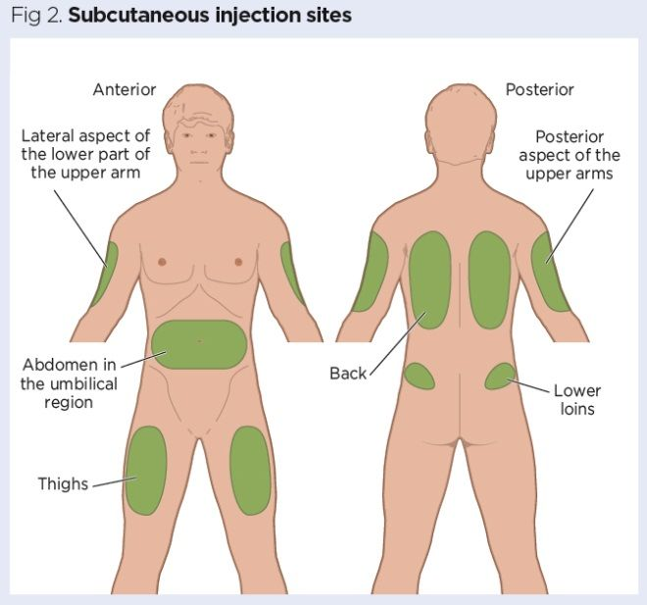
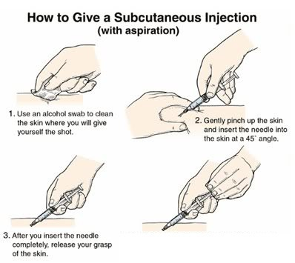

Common Questions

Q: How long does it take to see the results?
A: Results may vary! Depending on your body and your activity level, it may take longer to see results. Be patient and consistent!

Q: What kind of diet should I be eating with this plan?
A: It is important to eat healthy and exercise regularly. Bella recommends a variety of diets. Some of our favorites include Mediterranean, Whole30 or Paleo! Joining Weight Watchers or tracking on MyFitnessPal are also encouraged.

Q: If I have questions or concerns, who should I contact?
A: Please do not hesitate to contact us! If you have any questions, please email us at Health@bellawellness.org, or call Bella’s main office at (303) 789- 4968.

Q: What if I skip a dose?
A: Not to worry! Just pick up right where you left off. Remember, consistency is key. Try not to skip any doses.

Q: What if I run out of my supplies early before the full month is over?
A: Contact Bella to discuss a potential reorder with your provider!

Q: Once the weight is gone and the plan is over, how will I maintain my new weight?
A: Once your plan is complete, you will work with your provider 1:1 to discuss if you should do another round or create a specialized plan that works just for you!

*Disclaimer- results may vary. Bella Health + Wellness is not liable to compensate if results are not as desired.

